Group Assigment#2

Hans Kang, Ayoub El Makhchouni, Abeer Alrayes

**Supporting Document**

**Web Map:**

**Wireframe:**

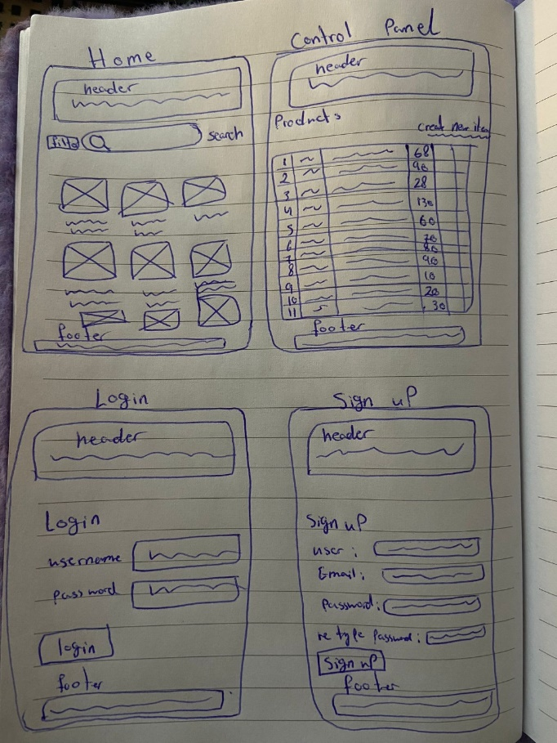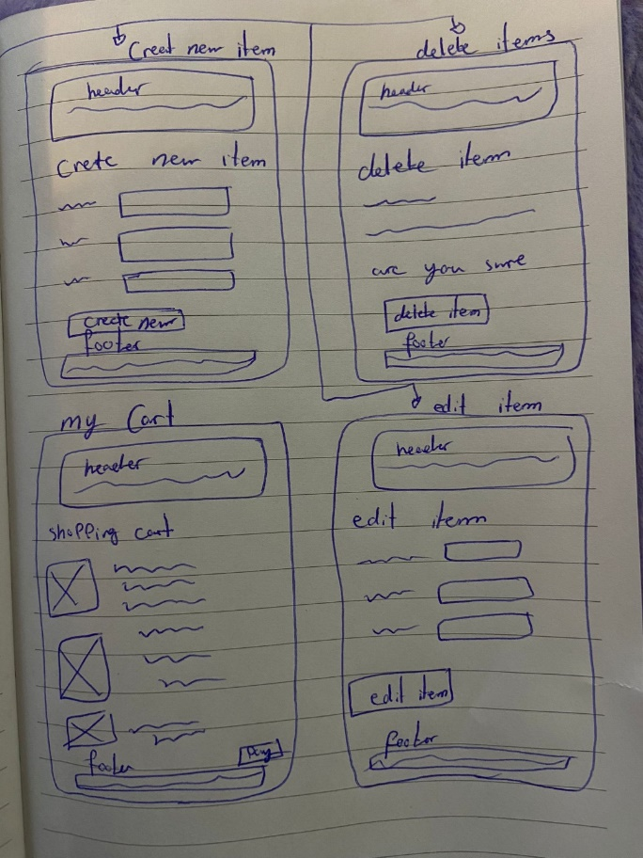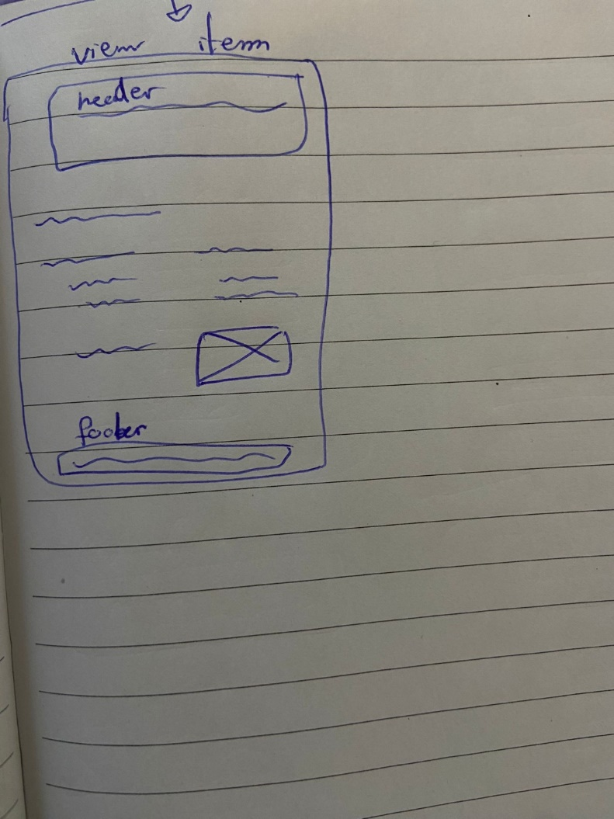

**Instruction Guide:**

1. **File Placement:**
   * Place the "assignment" file in the "Xamp -> htdocs" directory.
2. **Database Connection:**
   * Connect to XAMPP.
   * Import "Items.sql" into the database.
   * Import "User.sql" after importing "Items.sql".
   * Note: Ensure "Items.sql" is imported first as "User.sql" relies on it.
3. **Database Setup:**
   * "Items.sql" creates the "onlineshopping" database, and "User.sql" utilizes it.
4. **Accessing the Webpage:**
   * Proceed to our webpage using the following URL: <http://localhost/assignment/index.php>

**Description of database:**

**Items.sql** **–** it serves as a repository for item-related information. It functions as a back-end database where data modifications such as insertion updates or deletions are managed.

**User.sql –** It serves as a back-end database repository for storing user data. When a user signs up, their information is stored in back-end repository. During login process, the program retrieve data from user.sql to validate the user.

**Assigned Tasks**

**JavaScript:**

Validation – Hans Kang

**Database:**

Items.sql - Ayoub El Makhchouni

User.sql – Hans Kang

**Documentation:**

User Manual - Abeer Alrayes

Web Map - Abeer Alrayes

Wire Frame - Abeer Alrayes

Supporting Document Instruction guide – Hans Kang

**CSS:**

Style.css – Abeer Alrayes

**PHP Files:**

Index.php – Abeer Alrayes

Add_to_cart.php - Ayoub El Makhchouni, Hans Kang

Cart.php - Ayoub El Makhchouni, Hans Kang

Checkout.php - Ayoub El Makhchouni

Create.php - Ayoub El Makhchouni

CreateItems.php - Ayoub El Makhchouni

Database.php – Ayoub El Makhchouni, Hans Kang

Db_credentials.php – Hans Kang

Delete.php - Ayoub El Makhchouni

Edit.php - Ayoub El Makhchouni

FooterEm.php - Abeer Alrayes

HeaderEm.php - Abeer Alrayes

Login.php – Hans Kang

Login_database.php – Hans Kang

Logout.php – Hans Kang

New.php - Ayoub El Makhchouni

Remove_from_cart.php - Ayoub El Makhchouni

Search-box.php - Ayoub El Makhchouni

Show.php - Ayoub El Makhchouni

Signup.php – Hans Kang

Signup_Process.php – Hans Kang

Signup_Success.php – Hans Kang

**Images:**

Ayoub El Makhchouni